**Week 11 Worksheet: Support Vector Machines**

In these questions, you will be presented with data which we are trying to analyse and separate into red and blue, and in doing so creating a model which will allow the reliable classification of unseen data.

**Part A – Hardness/softness of margins**

These two graphs show the same set of data which has been fit with a linear kernel SVM, using different parameters to change the hardness of the margin.

Model A Model B

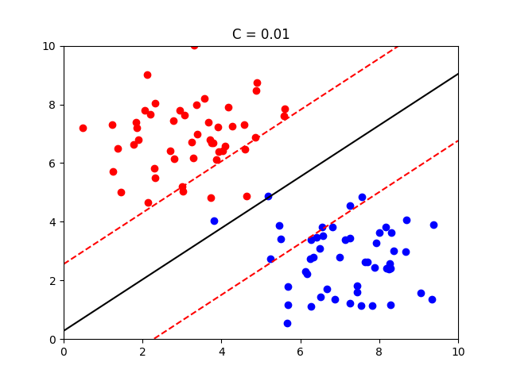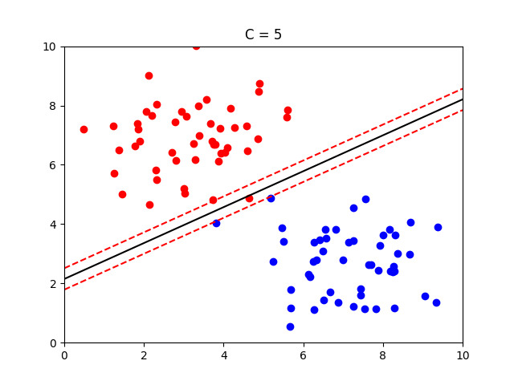

Explain the advantages of using Model B, with reference to:

* hard and soft margins
* how well the model will respond to new data
* overfitting/underfitting

Model B does not tend to have softer margins unlike Model A which does not make it prone to underfitting. Hence Model B would be a fairy accurate binary classifier whilst Model A would have a blue category bias. [not rly sure how to answer this]

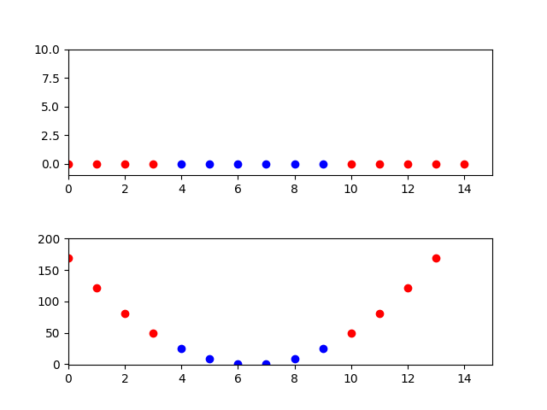**Part B – Transforming Data**

The data in the first figure on the right has been gathered based on one property and its corresponding classification, e.g. the data point where x = 3 is classified as red, and the data point where x = 8 is classified as blue.

Explain briefly how the data has been transformed to produce the figure below it, and why this is useful.

As the data shown above can’t linearly be separated into binary separations, a polynomial kernel function is used to map the data input points into higher dimensions in order to separate the classes more effectively. With a parabolic shape all data above about y=35 can be classified as a separate class.

**Part C – Beyond 3 Dimensions**

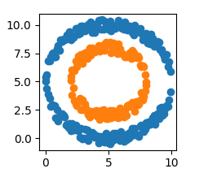

Explain briefly how a SVM separates these data, comparing the technique to the examples above.

This is a mod kernel and works in a similar way as to how a polynomial kernel function works except a mod function is applied to categorize it with an ellipse separation of data